

Form 5 Maths All-in-one (1112_Exam 1)
姓名:

Paper I ( 90 min) : Section A(1) : 11 Short Que.(67 marks) ,
(100 marks) Section B : 3 Long Que.(33 marks )
Paper II (60 min) : Section A : 30 Que.
Section B : 15 Que.

Chapter 1 – More about Quadratic Equations
A. Equations Reducible to Quadratic Equations
- Equations of Higher Degree
- Fractional Equations
- Equations with Square Root Signs
- Exponential Equations
- Logarithmic Equations
B. Practical Problems Leading to Quadratic Equations
C. Introduction to Complex Numbers
1. Imaginary Numbers
2. Complex Numbers ( * Equality of complex no.)
3. Operations of Complex Numbers

Chapter 4 – Locus
A. Concept of a Locus : a ___________of _________ which satisfy one/more given ________.
B. Description and Sketch of a Locus
C. Algebraic Equation of a Locus

Chapter 5 – Equations of Circles
A. Equations of Circles
1. Standard Form (Centre-Radius Form)
2. General Form
3. Other Methods of Finding the Equations of Circles
4. Determine a point inside/outside/on the circle.

B. Possible Intersection between a Straight Line and a Circle
1. Find the coordinates of the intersection(s) of a straight line and a circle.
2. Determine the number of intersections of a straight line and a circle.
3. Find the equations of tangents to a circle and tangent at a point.

Chapter 6 – Inequalities
A. Solving compound linear inequalities connected by AND (________)
B. Solving compound linear inequalities connected by OR (_______)
C. Solving quadratic inequalities
When a > 0
1. ${\text{ax}}^{2}+\text{bx}+c>0$ 2. ${\text{ax}}^{2}+\text{bx}+c<0$

Chapter 2 Basic Properties of Circles
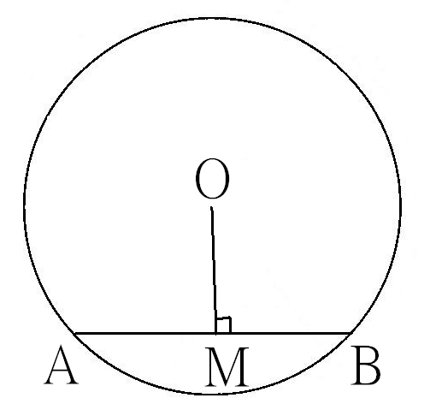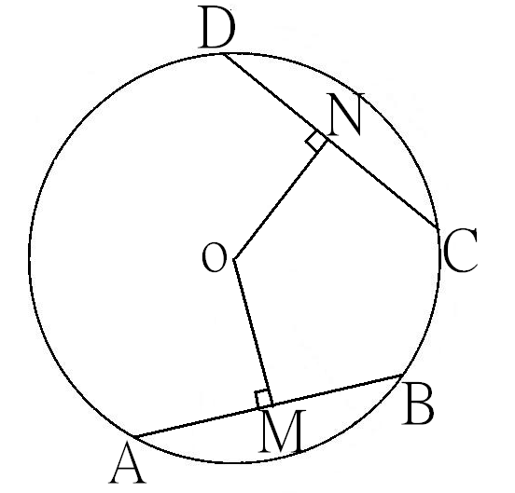A. Chords of a Circle
1. line from centre chord bisects chord
2. line joining centre to mid-pt of chord chord
3. equal chords, equidistant from centre
4. chords equidistant from centre are equal
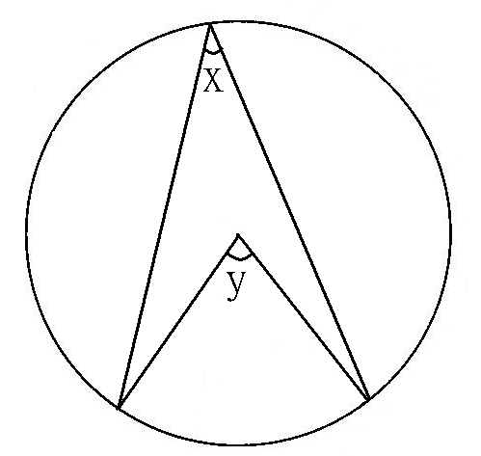
B. Angles in a Circle
5.$∠$at centre twice$∠$at ^{ce}
6.$∠$in semi-circle
7. converse of$∠$in semi-circle (prove diameter)
8.$∠s$in the same segment
C. Relationships among Arcs, Chords and Angles
9. equal$∠s$, equal arcs
O
x
y
D
C
B
A
A
D
10. equal$∠s$, equal chords
11. equal arcs, equal$∠s$
O
x
y
12. equal chords, equal$∠s$
13. equal chords, equal arcs
14. equal arcs, equal chords
B
C
15. arcs prop. to$∠s$at centre (only arcs)
16. arcs prop. to$∠s$at ^{ce} (only arcs)
D

A

B

C

D. Cyclic Quadrilaterals
17. opp.$∠s$, cyclic quad.
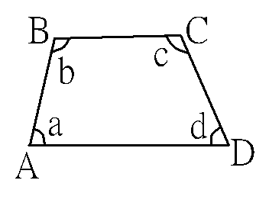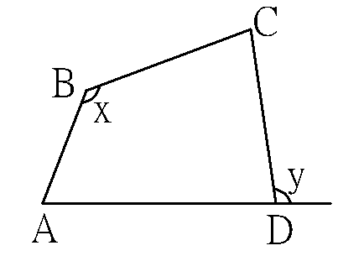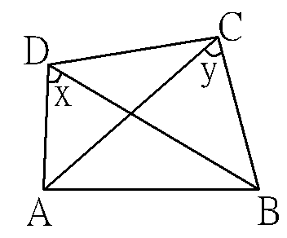18. ext.$∠$, cyclic quad.
19. opp.$∠s$supp. (Test 1 for concyclic)
20. ext.$∠$= int. opp.$∠$ (Test 2 for concyclic)
21. converse of$∠s$in the same segment (Test 3 for concyclic)
Chapter 3 Tangents to Circles
22. tangent ⊥ radius
P
O
T
Q

23.tangent prop. (i) TP = TQ,
P
T
Q
B
A
(ii) ∠POT = ∠QOT,
(iii) ∠PTO = ∠QTO.
24. ∠ in alt. segment
25. converse of tangent ⊥ radius (Test 1 for tangency)
26. converse of ∠ in alt. segment (Test 2 for tangency)

